ITALY
Italy is a parliamentary republic in Europe. Located in the heart of the Mediterranean Sea, Italy borders with France, Switzerland, Austria, Slovenia, San Marino and Vatican City. It is often referred to in Italy as lo Stivale (the Boot). With 61 million inhabitants, it is the fourth most populous member state.
Italy is regarded as one of the world's most industrialised nations and a leading country in world trade and exports. The country is well known for its creative and innovative business, a large and competitive agricultural sector and for its influential and high-quality automobile, machinery, food, design and fashion industry. Italy is the world's sixth largest manufacturing country.
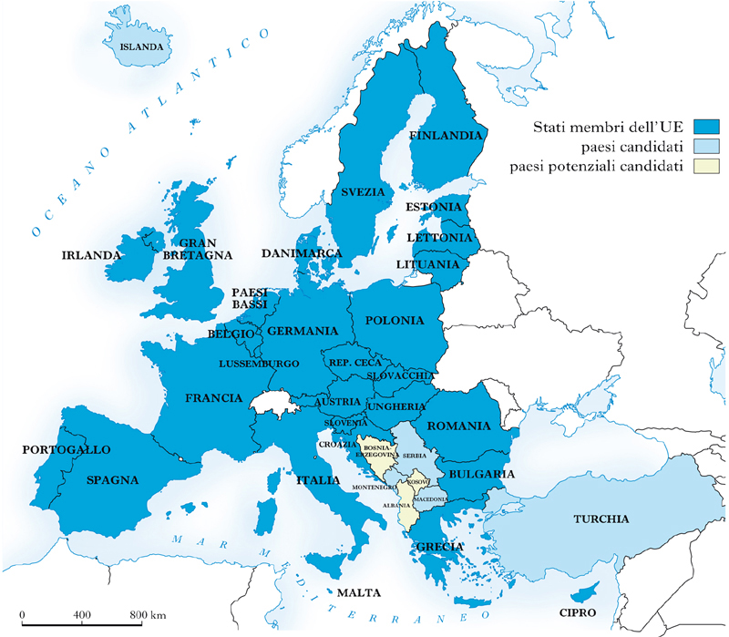

Italy is part of a monetary union, the Eurozone, and of the EU single market.
Italy is part of the European single market which represents more than 500 million consumers.
Several domestic commercial policies are determined by agreements among European Union (EU)
members and by EU legislation. Italy introduced the common European currency, the Euro in
2002. It is a member of the Eurozone which represents around 330 million citizens. Its monetary
policy is set by the European Central Bank.

GEOGRAPHY

Italy is located in Southern Europe. To the north, Italy is roughly delimited by the Alpine watershed enclosing the Po Valley and the Venetian Plain. To the south, it consists of the entirety of the Italian Peninsula and the two Mediterranean islands of Sicily and Sardinia, in addition to many smaller islands.
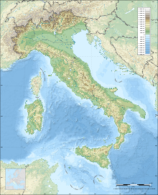
The Appenine Mountains form the peninsula's backbone and the Alps form most of its northern boundary, where Italy's highest point is located on Monte Bianco. The Po, Italy's longest river, flows from the Alps on the western border with France and crosses the Padan plain on its way to the Adriatic Sea. The five largest lakes are, in order of diminishing size: Garda, Maggiore, Como, Trasimeno and Bolsena.
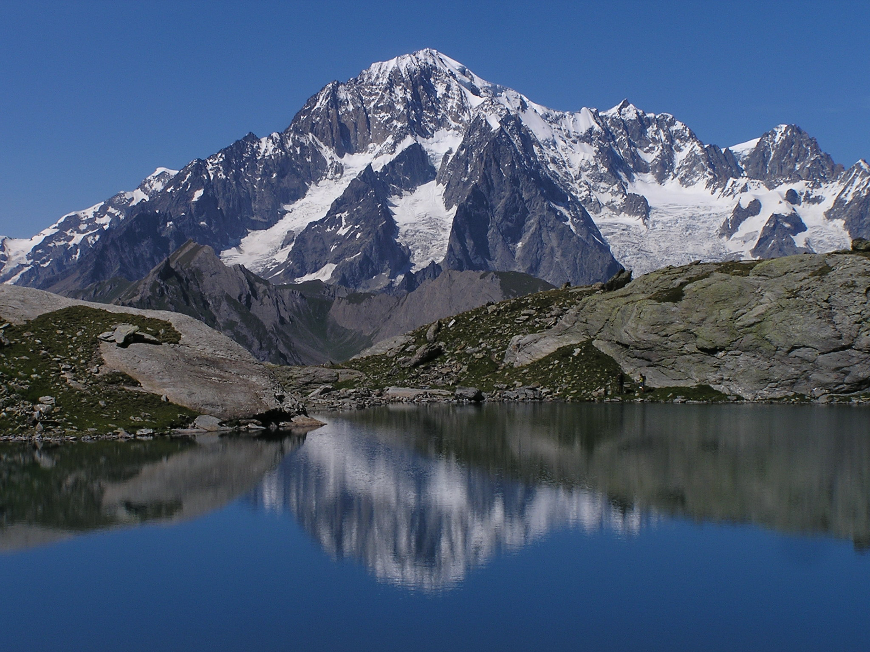

The country is situated at the meeting point of the Eurasian Plate and the African Plate, leading to considerable seismic and volcanic activity. There are 14 volcanoes in Italy, four of which are active: Etna, Stromboli, Vulcano and Vesuvius. Vesuvius is the only active volcano in mainland Europe and is most famous for the destruction of Pompeii and Herculanum in the euruption in 79 AD.

AGRICOLTURE
The Italian food industry is well known for the high quality and variety of its products. Of the total surface area in agricultural use: grain, olive tree, vineyards, citrus, sugar beets, and horticulture. The remainder is primarily dedicated to pastures and feed grains.
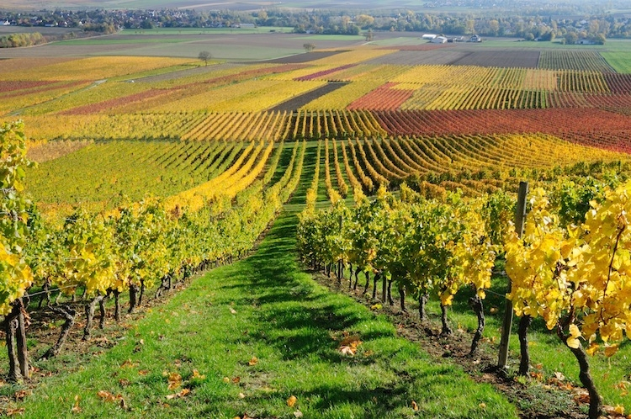

Italy is the world’s top win producer, and one of the leading in olive oil, fruits (apples, olives, grapes, oranges, lemons, pears, apricots, hazelnuts, peaches, cherries, plums, strawberries and kiwifruits), and vegetables (especially artichokes and tomatoes). The most famous Italian wines are probably the Tuscan Chianti and the Piedmontese Barolo. Other famous wines are Barbaresco, Barbera D’Asti, Brunello di Montalcino, Frascati, Montepulciano D’Abruzzo, Morellino di Scansano, and the sparkling wines Franiacorta and Prosecco. Quality goods in which Italy specialises, particularly the already mentioned wines and regional cheeses, are often protected under the quality assurance labels DOC/DOP. This geographical indication certificate, which is attributed by the European Union, is considered important in order to avoid confusion with low-quality mass-produced products.

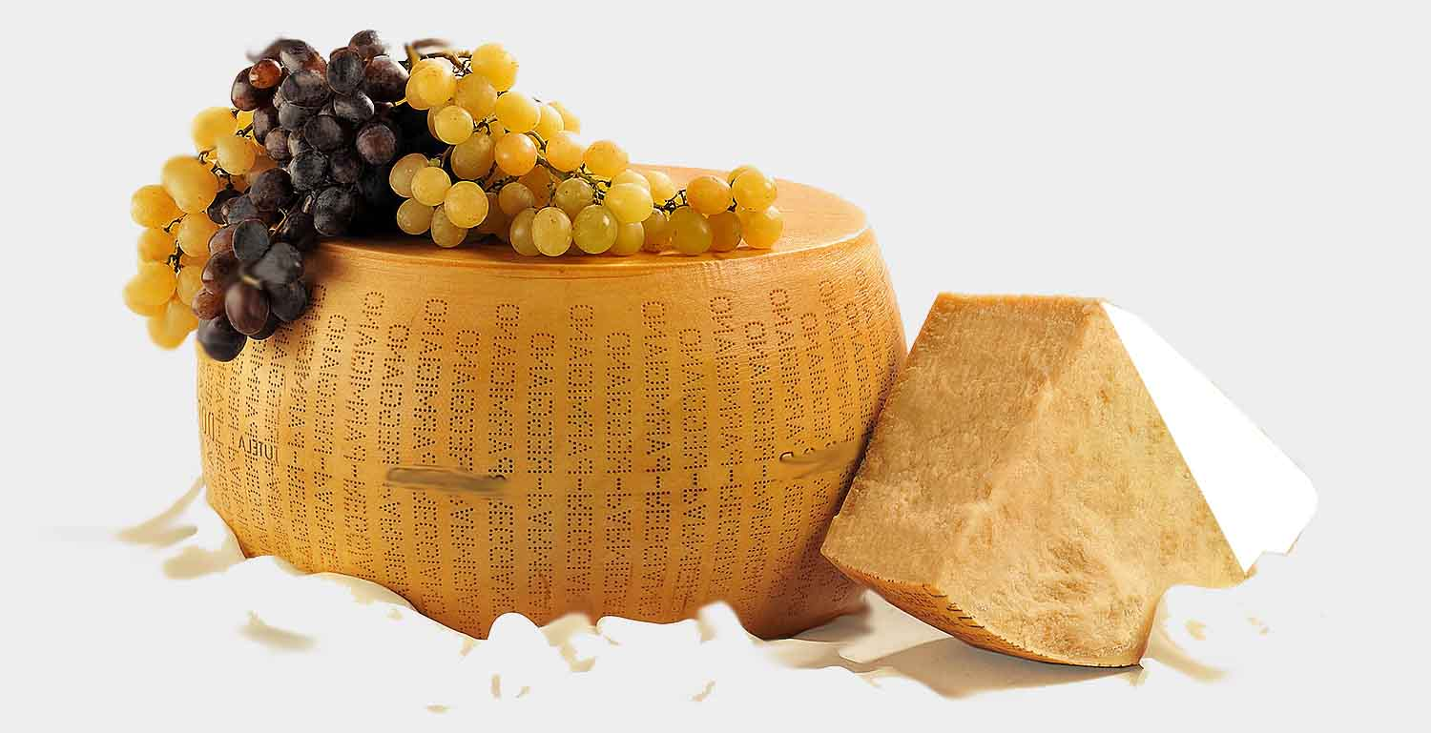

TOURISM
Italy is the fifth most visited country in international tourism arrivals, and the sixth highest tourism earner in the world. People mainly visit Italy for its art, cuisine, history, fashion and culture, its coastline and beaches, its mountains, and ancient monuments. Many northern cities are also able to use the Alps as an attraction for winter sports, while coastal southern cities have the Mediterranean Sea to draw tourists looking for sun. Italy is also home to fifty-one UNESCO world Heritage Sites.
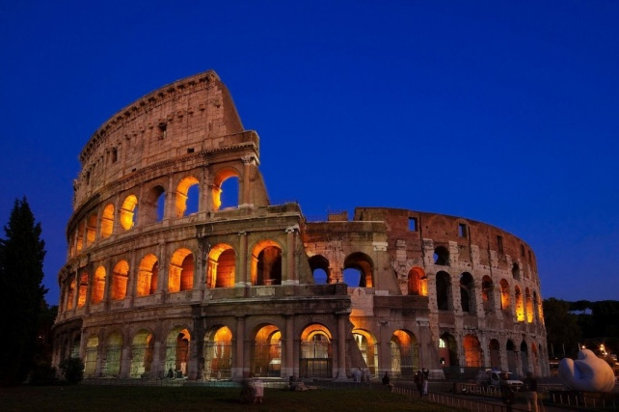Rome is the third most visited city in Europe and the 14th in the world, with an average of 7–10 million tourists a year; the Colosseum is the 39th most visited place in the world.
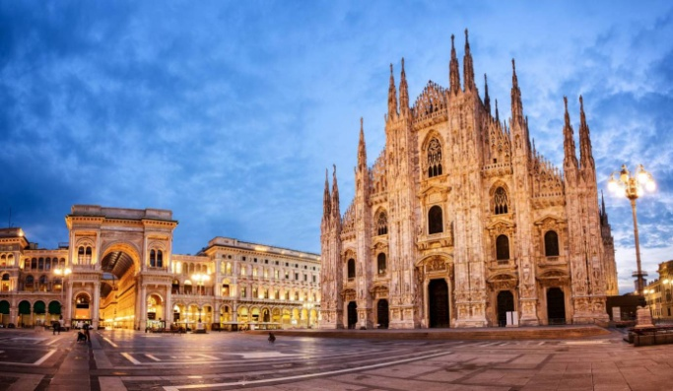Milan is the 7th EU's most important tourist destinations, and Italy's second, with 7.7 million arrivals.
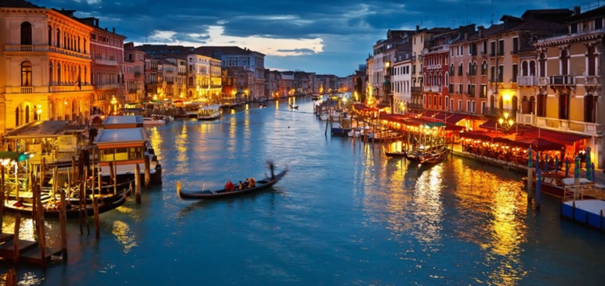Venice has an average of 50,000 tourists a day and in 2006 it was the world's 28th most internationally visited city, with 2.927 million international arrivals.

