ERASMUS + PROJECT
BREAK BARRIERS NO PREJUDICES
ITC “L. EINAUDI” ORTONA

ORTONA

Ortona is a small town in Abruzzo, on the eastern coast of Italy.
There are a lot of monuments and structures that you can visit. You
can find the Aragonese castle overviewing the sea and the theatre Francesco Paolo Tosti the cultural heart of the city.

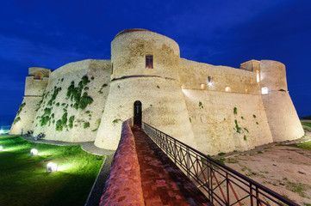

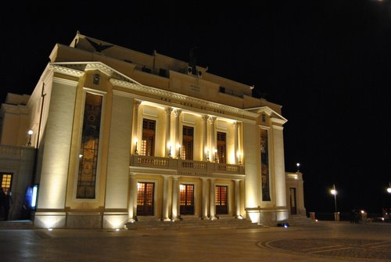
Ortona has a beautiful history of navigators and one of them was Leone Acciaiuoli that in one of his travels found the bones of Saint Thomas the Apostle guarded in the cathedral that you can visit in the centre of Ortona. Infact in honor of him, every first Sunday of May, the Patron Saint’s day takes place and plenary indulgence is given.

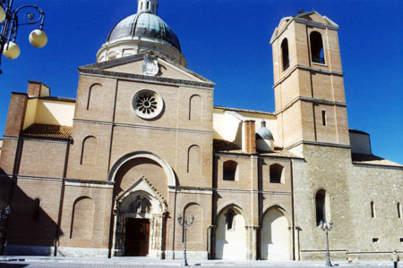

Ortona is home of several touristic beaches and moreover you can go down the long promenade overviewing the port and the sea, the “Orientale”. During the summer months, there are a lot of visitors that enjoy a good ice cream or a good walk on this beautiful promenade.

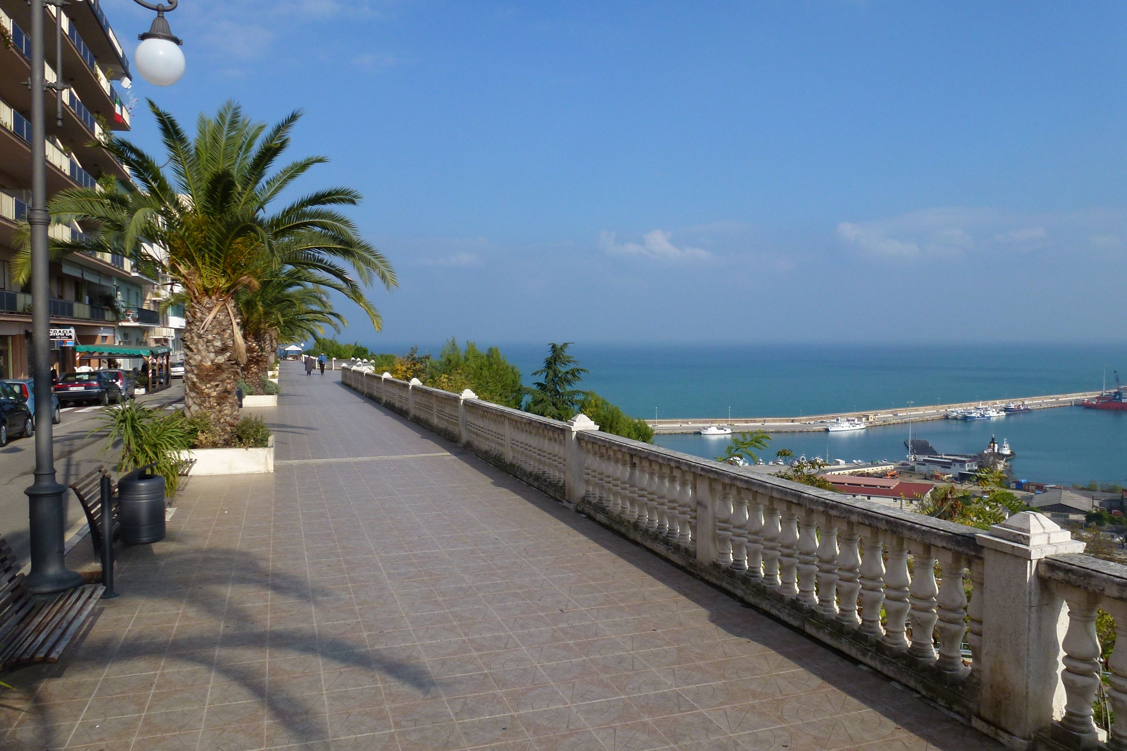
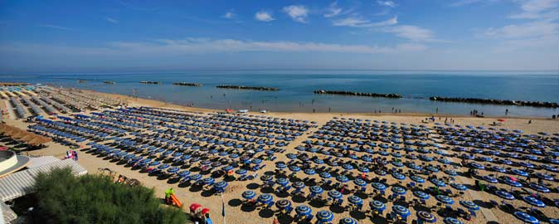

Ortona was involved during World War II and infact there is the Moro River Canadian War Cemetery where there are the mortal remains of 1,615 soldiers. During the war Ortona was the site of a battle between German and Canadian soldiers. The town was almost completely destroyed with more than 1,300 civilian victims. The ferocity of the battle of Ortona led it to be known as the “Little Stalingrad”.

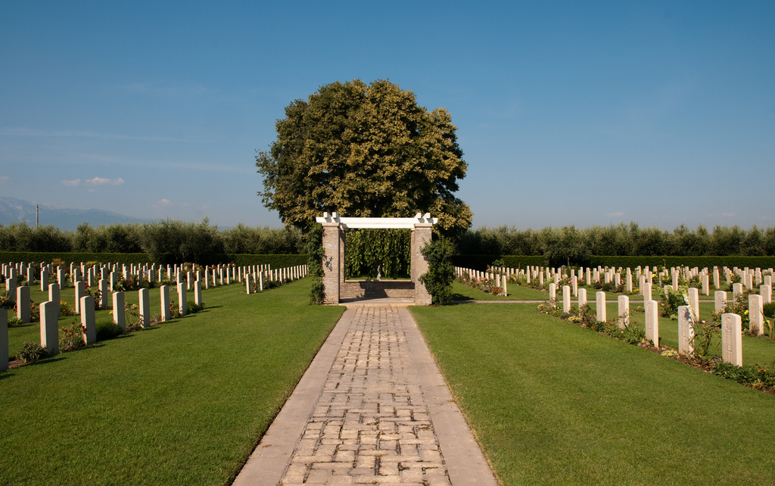

Ortona is very important for the production of wines and olive oil.

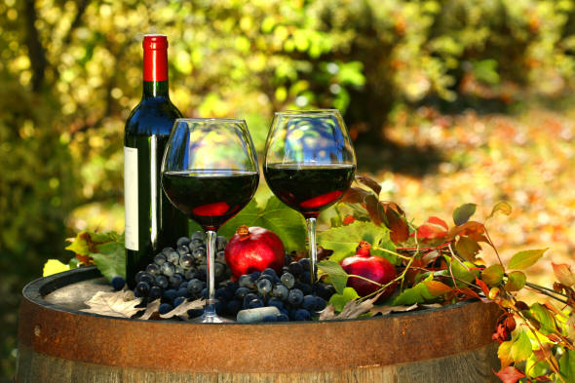
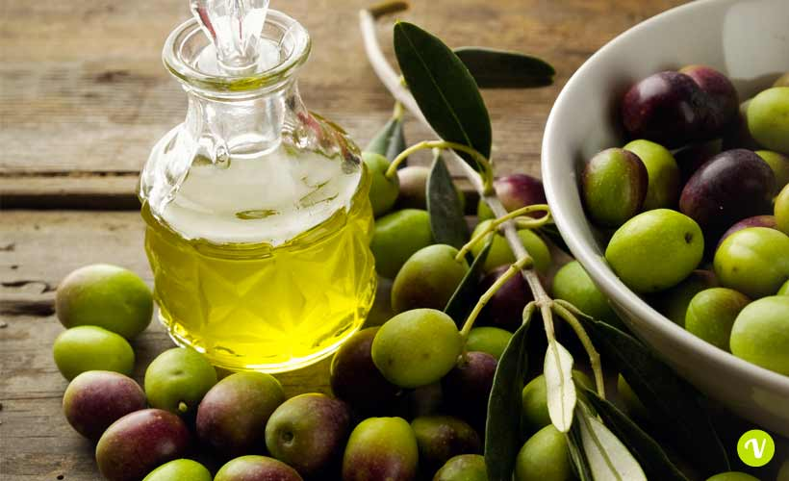

The cuisine of Ortona is very famous too. In many restaurants you can eat different types of fish cooked in every manner.
Among the typical dishes you can find the “Brodetto”, fish soup flavoured with tomatoes and peperoncino, “Spaghetti con pelosi”, or seafood, fried fish of the Adriatic. Among the desserts you can taste the “nevole”, cone-shaped rolled wafers.

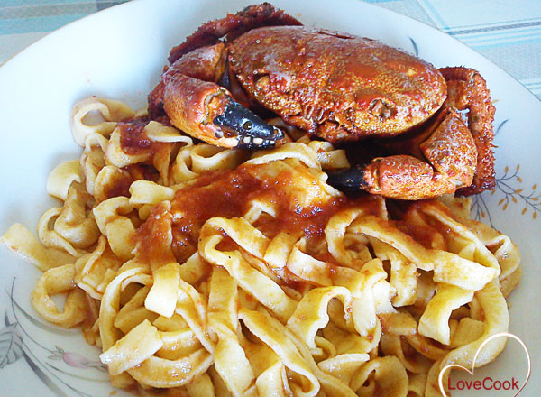
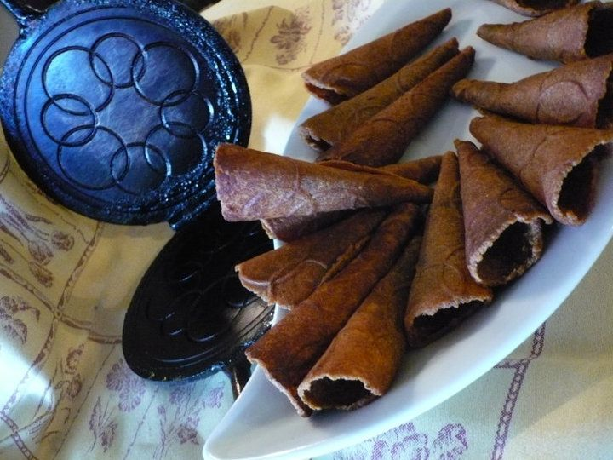

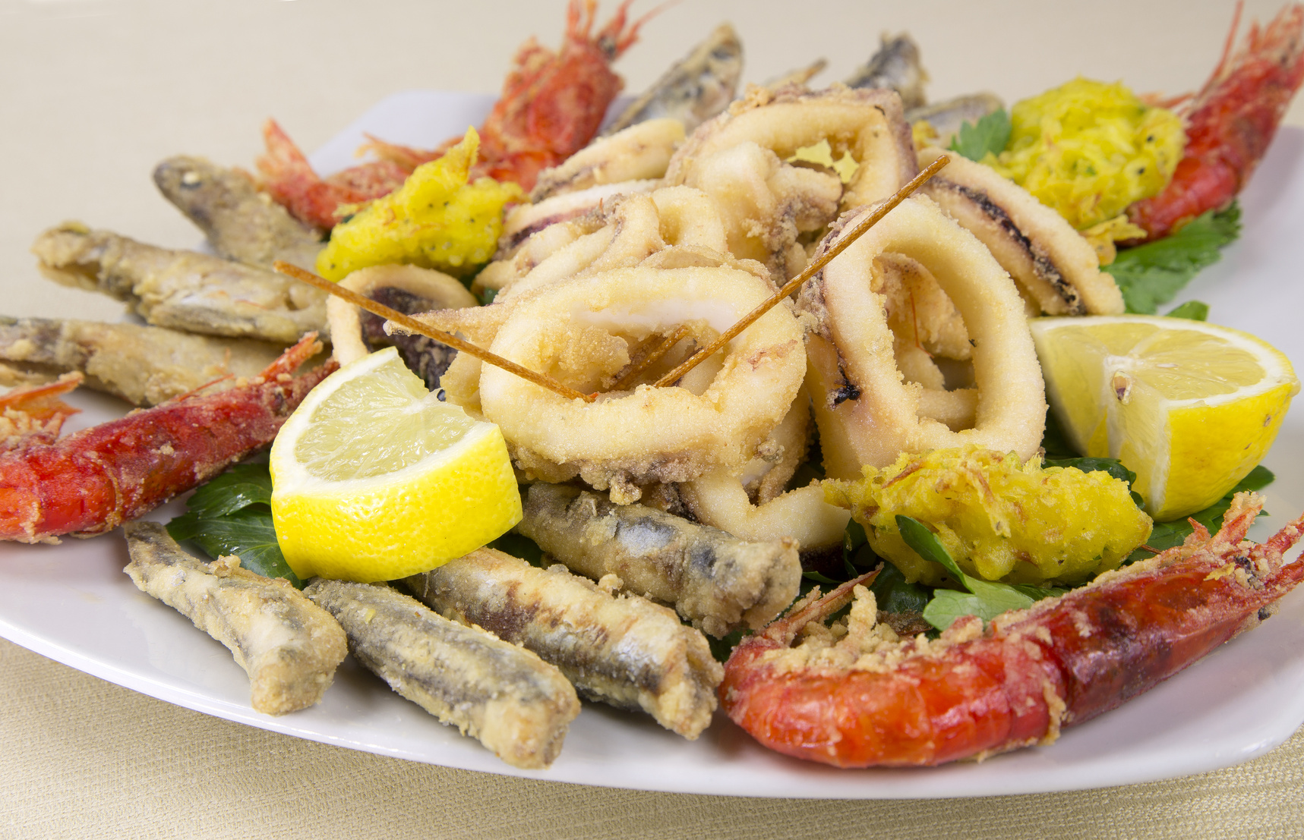

After Ortona you can also visit the “Trabocchi” , the strange “fishing machines”. They are completely made of wood, their base is supported by long puncheons, from where the fisherman can batter down the fishnet. Probably in the past people created these machines to fish without going directly to sea.

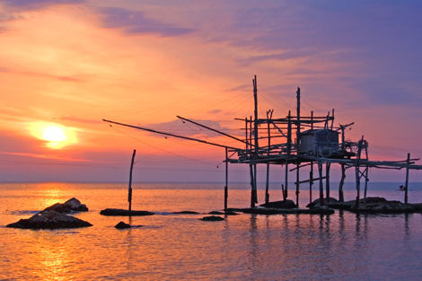
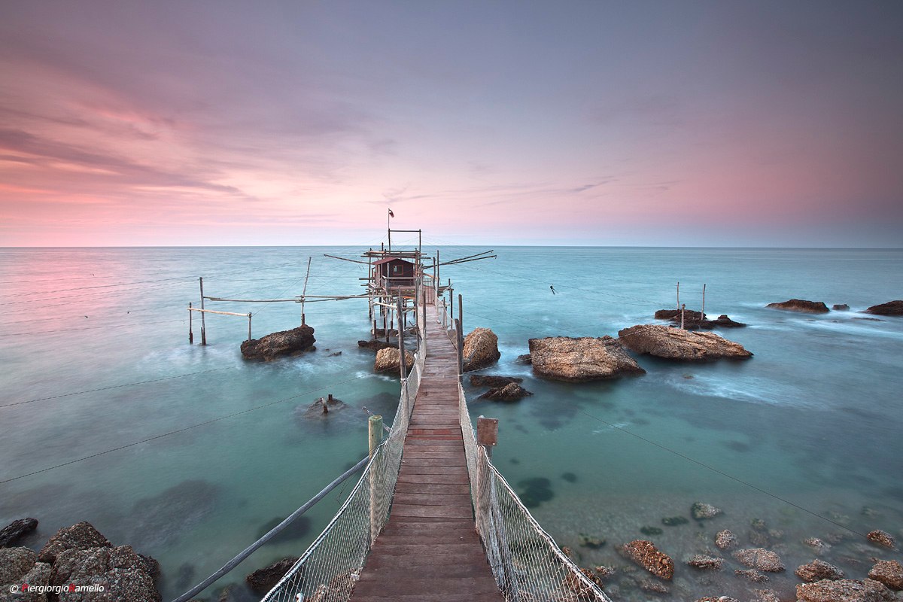

Ortona is also famous for its port that has an important role for the local economy.

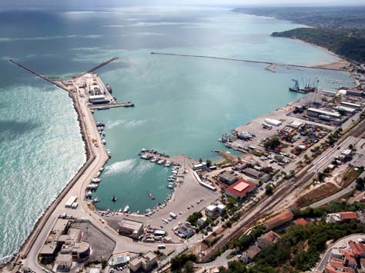

Ortona, a very nice place to visit, a perfect location for food and wine lovers, a good combination of culture and fun.

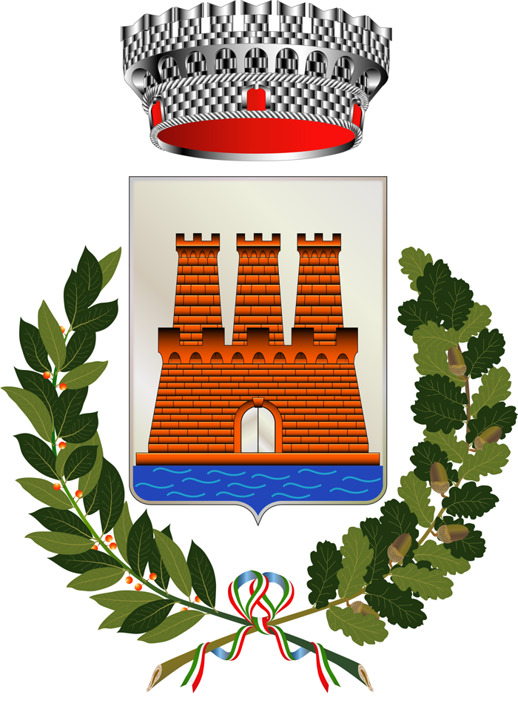
COME TO ORTONA, YOU'RE WELCOME!

